**Awesome Quantum Machine Learning**

A curated list of awesome quantum machine learning algorithms,study materials,libraries and software (by language).

Table of Contents

* [INTRODUCTION](https://github.com/krishnakumarsekar/awesome-quantum-machine-learning#introduction)
  + [Why Quantum Machine Learning?](https://github.com/krishnakumarsekar/awesome-quantum-machine-learning#introduction-why-quantum-machine-learning)
* [BASICS](https://github.com/krishnakumarsekar/awesome-quantum-machine-learning#basics)
  + [What is Quantum Mechanics?](https://github.com/krishnakumarsekar/awesome-quantum-machine-learning#basics-what-quantum-mechanics)
  + [What is Quantum Computing?](https://github.com/krishnakumarsekar/awesome-quantum-machine-learning#basics-what-quantum-computing)
  + [What is Topological Quantum Computing?](https://github.com/krishnakumarsekar/awesome-quantum-machine-learning#basics-what-topological-quantum-computing)
  + [Quantum Computing vs Classical Computing](https://github.com/krishnakumarsekar/awesome-quantum-machine-learning#basics-quantum-classical-vs)
* [QUANTUM COMPUTING](https://github.com/krishnakumarsekar/awesome-quantum-machine-learning#quantumcomputing)
  + [Atom Structure](https://github.com/krishnakumarsekar/awesome-quantum-machine-learning#quantumcomputing-atom-structure)
  + [Photon wave](https://github.com/krishnakumarsekar/awesome-quantum-machine-learning#quantumcomputing-photon-wave)
  + [Electron Fluctuation or spin](https://github.com/krishnakumarsekar/awesome-quantum-machine-learning#quantumcomputing-elecfluctuation-spin)
  + [States](https://github.com/krishnakumarsekar/awesome-quantum-machine-learning#quantumcomputing-states)
  + [SuperPosition](https://github.com/krishnakumarsekar/awesome-quantum-machine-learning#quantumcomputing-superposition)
  + [SuperPosition specific for machine learning(Quantum Walks)](https://github.com/krishnakumarsekar/awesome-quantum-machine-learning#quantumcomputing-superpostion-machinelearning)
  + [Classical Bit](https://github.com/krishnakumarsekar/awesome-quantum-machine-learning#quantumcomputing-classicalbit)
  + [Quantum Bit or Qubit or Qbit](https://github.com/krishnakumarsekar/awesome-quantum-machine-learning#quantumcomputing-qubit)
  + [Basic Gates in Quantum Computing](https://github.com/krishnakumarsekar/awesome-quantum-machine-learning#quantumcomputing-basicgates)
  + [Quantum Diode](https://github.com/krishnakumarsekar/awesome-quantum-machine-learning#quantumcomputing-diode)
  + [Quantum Transistor](https://github.com/krishnakumarsekar/awesome-quantum-machine-learning#quantumcomputing-transistor)
  + [Quantum Processor](https://github.com/krishnakumarsekar/awesome-quantum-machine-learning#quantumcomputing-processor)
  + [Quantum Registery QRAM](https://github.com/krishnakumarsekar/awesome-quantum-machine-learning#quantumcomputing-qram)
  + [Quantum Entanglement](https://github.com/krishnakumarsekar/awesome-quantum-machine-learning#quantumcomputing-entanglement)
* [QUANTUM COMPUTING MACHINE LEARNING BRIDGE](https://github.com/krishnakumarsekar/awesome-quantum-machine-learning#qcmlbridge)
  + [Complex Numbers](https://github.com/krishnakumarsekar/awesome-quantum-machine-learning#qcmlbridge-complexNumbers)
  + [Tensors](https://github.com/krishnakumarsekar/awesome-quantum-machine-learning#qcmlbridge-tensors)
  + [Tensors Network](https://github.com/krishnakumarsekar/awesome-quantum-machine-learning#qcmlbridge-tensors-network)
  + [Oracle](https://github.com/krishnakumarsekar/awesome-quantum-machine-learning#qcmlbridge-oracle)
  + [Hadamard transform](https://github.com/krishnakumarsekar/awesome-quantum-machine-learning#qcmlbridge-hadamard)
  + [Hilbert Space](https://github.com/krishnakumarsekar/awesome-quantum-machine-learning#qcmlbridge-hilbert)
  + [eigenvalues and eigenvectors](https://github.com/krishnakumarsekar/awesome-quantum-machine-learning#qcmlbridge-eigen)
  + [Schr¨odinger Operators](https://github.com/krishnakumarsekar/awesome-quantum-machine-learning#qcmlbridge-schrodinger)
  + [Quantum lambda calculus](https://github.com/krishnakumarsekar/awesome-quantum-machine-learning#qcmlbridge-lamda)
  + [Quantum Amplitute Phase](https://github.com/krishnakumarsekar/awesome-quantum-machine-learning#qcmlbridge-amp-phase)
  + [Qubits Encode and Decode](https://github.com/krishnakumarsekar/awesome-quantum-machine-learning#qcmlbridge-encode-decode)
  + [convert classical bit to qubit](https://github.com/krishnakumarsekar/awesome-quantum-machine-learning#qcmlbridge-classical-qubit)
  + [Quantum Dirac and Kets](https://github.com/krishnakumarsekar/awesome-quantum-machine-learning#qcmlbridge-dirac-ket)
  + [Quantum Complexity](https://github.com/krishnakumarsekar/awesome-quantum-machine-learning#qcmlbridge-complexity)
  + [Arbitrary State Generation](https://github.com/krishnakumarsekar/awesome-quantum-machine-learning#qcmlbridge-arbitarystategeneration)
* [QUANTUM ALGORITHMS](https://github.com/krishnakumarsekar/awesome-quantum-machine-learning#quantumalgorithms)
  + [Quantum Fourier Transform](https://github.com/krishnakumarsekar/awesome-quantum-machine-learning#quantumalgorithms-fourier)
  + [Variational-Quantum-Eigensolver](https://github.com/krishnakumarsekar/awesome-quantum-machine-learning#quantumalgorithms-quantumeigensolver)
  + [Grovers Algorithm](https://github.com/krishnakumarsekar/awesome-quantum-machine-learning#quantumalgorithms-grover)
  + [Shor's algorithm](https://github.com/krishnakumarsekar/awesome-quantum-machine-learning#quantumalgorithms-shors)
  + [Hamiltonian Oracle Model](https://github.com/krishnakumarsekar/awesome-quantum-machine-learning#quantumalgorithms-hamiltonian)
  + [Bernstein-Vazirani Algorithm](https://github.com/krishnakumarsekar/awesome-quantum-machine-learning#quantumalgorithms-Bernsteinvazirani)
  + [Simon’s Algorithm](https://github.com/krishnakumarsekar/awesome-quantum-machine-learning#quantumalgorithms-simons)
  + [Deutsch-Jozsa Algorithm](https://github.com/krishnakumarsekar/awesome-quantum-machine-learning#quantumalgorithms-deutschjozsa)
  + [Gradient Descent](https://github.com/krishnakumarsekar/awesome-quantum-machine-learning#quantumalgorithms-gradient-descent)
  + [Phase Estimation](https://github.com/krishnakumarsekar/awesome-quantum-machine-learning#quantumalgorithms-phase-estimation)
  + [Haar Tansform](https://github.com/krishnakumarsekar/awesome-quantum-machine-learning#quantumalgorithms-haar)
  + [Quantum Ridgelet Transform](https://github.com/krishnakumarsekar/awesome-quantum-machine-learning#quantumalgorithms-ridgelet)
  + [Quantum NP Problem](https://github.com/krishnakumarsekar/awesome-quantum-machine-learning#quantumalgorithms-npproblem)
* [QUANTUM MACHINE LEARNING ALGORITHMS](https://github.com/krishnakumarsekar/awesome-quantum-machine-learning#quantumalgorithmsml)
  + [Quantum K-Nearest Neighbour](https://github.com/krishnakumarsekar/awesome-quantum-machine-learning#quantumalgorithmsml-qknn)
  + [Quantum K-Means](https://github.com/krishnakumarsekar/awesome-quantum-machine-learning#quantumalgorithmsml-kmeans)
  + [Quantum Fuzzy C-Means](https://github.com/krishnakumarsekar/awesome-quantum-machine-learning#quantumalgorithmsml-qfcm)
  + [Quantum Support Vector Machine](https://github.com/krishnakumarsekar/awesome-quantum-machine-learning#quantumalgorithmsml-svm)
  + [Quantum Genetic Algorithm](https://github.com/krishnakumarsekar/awesome-quantum-machine-learning#quantumalgorithmsml-genetic)
  + [Quantum Hidden Morkov Models](https://github.com/krishnakumarsekar/awesome-quantum-machine-learning#quantumalgorithmsml-hmm)
  + [Quantum state classification with Bayesian methods](https://github.com/krishnakumarsekar/awesome-quantum-machine-learning#quantumalgorithmsml-bayesian)
  + [Quantum Ant Colony Optimization](https://github.com/krishnakumarsekar/awesome-quantum-machine-learning#quantumalgorithmsml-antcolony)
  + [Quantum Cellular Automata](https://github.com/krishnakumarsekar/awesome-quantum-machine-learning#quantumalgorithmsml-caautomata)
  + [Quantum Classification using Principle Component Analysis](https://github.com/krishnakumarsekar/awesome-quantum-machine-learning#quantumalgorithmsml-pca)
  + [Quantum Inspired Evolutionary Algorithm](https://github.com/krishnakumarsekar/awesome-quantum-machine-learning#quantumalgorithmsml-evolutionary)
  + [Quantum Approximate Optimization Algorithm](https://github.com/krishnakumarsekar/awesome-quantum-machine-learning#quantumalgorithmsml-qaoa)
  + [Quantum Elephant Herding Optimization](https://github.com/krishnakumarsekar/awesome-quantum-machine-learning#quantumalgorithmsml-qeho)
  + [Quantum-behaved Particle Swarm Optimization](https://github.com/krishnakumarsekar/awesome-quantum-machine-learning#quantumalgorithmsml-qpso)
  + [Quantum Annealing Expectation-Maximization](https://github.com/krishnakumarsekar/awesome-quantum-machine-learning#quantumalgorithmsml-qaem)
* [QAUNTUM NEURAL NETWORK](https://github.com/krishnakumarsekar/awesome-quantum-machine-learning#qnn)
  + [Quantum perceptrons](https://github.com/krishnakumarsekar/awesome-quantum-machine-learning#qnn-perceptron)
  + [Qurons](https://github.com/krishnakumarsekar/awesome-quantum-machine-learning#qnn-qurons)
  + [Quantum Auto Encoder](https://github.com/krishnakumarsekar/awesome-quantum-machine-learning#qnn-autoencoder)
  + [Quantum Annealing](https://github.com/krishnakumarsekar/awesome-quantum-machine-learning#qnn-annealing)
  + [Photonic Implementation of Quantum Neural Network](https://github.com/krishnakumarsekar/awesome-quantum-machine-learning#qnn-photonicqnn)
  + [Quantum Feed Forward Neural Network](https://github.com/krishnakumarsekar/awesome-quantum-machine-learning#qnn-feedforward)
  + [Quantum Boltzman Neural Network](https://github.com/krishnakumarsekar/awesome-quantum-machine-learning#qnn-boltzman)
  + [Quantum Neural Net Weight Storage](https://github.com/krishnakumarsekar/awesome-quantum-machine-learning#qnn-weightstorage)
  + [Quantum Upside Down Neural Net](https://github.com/krishnakumarsekar/awesome-quantum-machine-learning#qnn-upsidedown)
  + [Quantum Hamiltonian Neural Net](https://github.com/krishnakumarsekar/awesome-quantum-machine-learning#qnn-hamiltoniannet)
  + [QANN](https://github.com/krishnakumarsekar/awesome-quantum-machine-learning#qnn-qann)
  + [QPN](https://github.com/krishnakumarsekar/awesome-quantum-machine-learning#qnn-qpn)
  + [SAL](https://github.com/krishnakumarsekar/awesome-quantum-machine-learning#qnn-sal)
  + [Quantum Hamiltonian Learning](https://github.com/krishnakumarsekar/awesome-quantum-machine-learning#qnn-hamiltonianlearning)
  + [Compressed Quantum Hamiltonian Learning](https://github.com/krishnakumarsekar/awesome-quantum-machine-learning#qnn-compressedhamiltonianlearning)
* [QAUNTUM STATISTICAL DATA ANALYSIS](https://github.com/krishnakumarsekar/awesome-quantum-machine-learning#quantumstatistics)
  + [Quantum Probability Theory](https://github.com/krishnakumarsekar/awesome-quantum-machine-learning#quantumstatistics-probabilitytheory)
  + [Kolmogorovian Theory](https://github.com/krishnakumarsekar/awesome-quantum-machine-learning#quantumstatistics-kolmogorovian)
  + [Quantum Measurement Problem](https://github.com/krishnakumarsekar/awesome-quantum-machine-learning#quantumstatistics-measurementproblem)
  + [Intuitionistic Logic](https://github.com/krishnakumarsekar/awesome-quantum-machine-learning#quantumstatistics-intuitionistic)
  + [Heyting Algebra](https://github.com/krishnakumarsekar/awesome-quantum-machine-learning#quantumstatistics-heytingalgebra)
  + [Quantum Filtering](https://github.com/krishnakumarsekar/awesome-quantum-machine-learning#quantumstatistics-quantumfiltering)
  + [Paradoxes](https://github.com/krishnakumarsekar/awesome-quantum-machine-learning#quantumstatistics-paradoxes)
  + [Quantum Stochastic Process](https://github.com/krishnakumarsekar/awesome-quantum-machine-learning#quantumstatistics-stochasticprocess)
  + [Double Negation](https://github.com/krishnakumarsekar/awesome-quantum-machine-learning#quantumstatistics-doublenegation)
  + [Quantum Stochastic Calculus](https://github.com/krishnakumarsekar/awesome-quantum-machine-learning#quantumstatistics-stochasticcalculus)
  + [Hamiltonian Calculus](https://github.com/krishnakumarsekar/awesome-quantum-machine-learning#quantumstatistics-hamiltoniancalculus)
  + [Quantum Ito's Formula](https://github.com/krishnakumarsekar/awesome-quantum-machine-learning#quantumstatistics-itosformula)
  + [Quantum Stochastic Differential Equations(QSDE)](https://github.com/krishnakumarsekar/awesome-quantum-machine-learning#quantumstatistics-qsde)
  + [Quantum Stochastic Integration](https://github.com/krishnakumarsekar/awesome-quantum-machine-learning#quantumstatistics-stochasticintegration)
  + [Itō Integral](https://github.com/krishnakumarsekar/awesome-quantum-machine-learning#quantumstatistics-it%C5%8Dintegral)
  + [Quasiprobability Distributions](https://github.com/krishnakumarsekar/awesome-quantum-machine-learning#quantumstatistics-quasiprobabilitydistributions)
  + [Quantum Wiener Processes](https://github.com/krishnakumarsekar/awesome-quantum-machine-learning#quantumstatistics-quantumwienerprocesses)
  + [Quantum Statistical Ensemble](https://github.com/krishnakumarsekar/awesome-quantum-machine-learning#quantumstatistics-statisticalensemble)
  + [Quantum Density Operator or Density Matrix](https://github.com/krishnakumarsekar/awesome-quantum-machine-learning#quantumstatistics-densityoperator)
  + [Gibbs Canonical Ensemble](https://github.com/krishnakumarsekar/awesome-quantum-machine-learning#quantumstatistics-gibbscanonicalensemble)
  + [Quantum Mean](https://github.com/krishnakumarsekar/awesome-quantum-machine-learning#quantumstatistics-mean)
  + [Quantum Variance](https://github.com/krishnakumarsekar/awesome-quantum-machine-learning#quantumstatistics-variance)
  + [Envariance](https://github.com/krishnakumarsekar/awesome-quantum-machine-learning#quantumstatistics-envariance)
  + [Polynomial Optimization](https://github.com/krishnakumarsekar/awesome-quantum-machine-learning#quantumstatistics-polynomialoptimization)
  + [Quadratic Unconstrained Binary Optimization](https://github.com/krishnakumarsekar/awesome-quantum-machine-learning#quantumstatistics-qubo)
  + [Quantum Gradient Descent](https://github.com/krishnakumarsekar/awesome-quantum-machine-learning#quantumstatistics-quantumgradientdescent)
  + [Quantum Based Newton's Method for Constrained Optimization](https://github.com/krishnakumarsekar/awesome-quantum-machine-learning#quantumstatistics-newtonmethodconstrainedoptimization)
  + [Quantum Based Newton's Method for UnConstrained Optimization](https://github.com/krishnakumarsekar/awesome-quantum-machine-learning#quantumstatistics-newtonmethodunconstrainedoptimization)
  + [Quantum Ensemble](https://github.com/krishnakumarsekar/awesome-quantum-machine-learning#quantumstatistics-quantumensemble)
  + [Quantum Topology](https://github.com/krishnakumarsekar/awesome-quantum-machine-learning#quantumstatistics-quantumtopology)
  + [Quantum Topological Data Analysis](https://github.com/krishnakumarsekar/awesome-quantum-machine-learning#quantumstatistics-quantumtopologicaldataanalysis)
  + [Quantum Bayesian Hypothesis](https://github.com/krishnakumarsekar/awesome-quantum-machine-learning#quantumstatistics-quantumbayesianhypothesis)
  + [Quantum Statistical Decision Theory](https://github.com/krishnakumarsekar/awesome-quantum-machine-learning#quantumstatistics-quantumstatisticaldecisiontheory)
  + [Quantum Minimax Theorem](https://github.com/krishnakumarsekar/awesome-quantum-machine-learning#quantumstatistics-quantumminimaxtheorem)
  + [Quantum Hunt-Stein Theorem](https://github.com/krishnakumarsekar/awesome-quantum-machine-learning#quantumstatistics-quantumhuntsteintheorem)
  + [Quantum Locally Asymptotic Normality](https://github.com/krishnakumarsekar/awesome-quantum-machine-learning#quantumstatistics-quantumlocalasymptoticnormality)
  + [Quantum Ising Model](https://github.com/krishnakumarsekar/awesome-quantum-machine-learning#quantumstatistics-isingmodel)
  + [Quantum Metropolis Sampling](https://github.com/krishnakumarsekar/awesome-quantum-machine-learning#quantumstatistics-metropolissampling)
  + [Quantum Monte Carlo Approximation](https://github.com/krishnakumarsekar/awesome-quantum-machine-learning#quantumstatistics-montecarloapproximation)
  + [Quantum Bootstrapping](https://github.com/krishnakumarsekar/awesome-quantum-machine-learning#quantumstatistics-bootstrapping)
  + [Quantum Bootstrap Aggregation](https://github.com/krishnakumarsekar/awesome-quantum-machine-learning#quantumstatistics-bootstrapaggregation)
  + [Quantum Decision Tree Classifier](https://github.com/krishnakumarsekar/awesome-quantum-machine-learning#quantumstatistics-decisiontreeclassifier)
  + [Quantum Outlier Detection](https://github.com/krishnakumarsekar/awesome-quantum-machine-learning#quantumstatistics-outlierdetection)
  + [Cholesky-Decomposition for Quantum Chemistry](https://github.com/krishnakumarsekar/awesome-quantum-machine-learning#quantumstatistics-choleskydecomposition)
  + [Quantum Statistical Inference](https://github.com/krishnakumarsekar/awesome-quantum-machine-learning#quantumstatistics-quantumstatisticalinference)
  + [Asymptotic Quantum Statistical Inference](https://github.com/krishnakumarsekar/awesome-quantum-machine-learning#quantumstatistics-quantumstatisticalinferenceasymptotic)
  + [Quantum Gaussian Mixture Modal](https://github.com/krishnakumarsekar/awesome-quantum-machine-learning#quantumstatistics-qgmm)
  + [Quantum t-design](https://github.com/krishnakumarsekar/awesome-quantum-machine-learning#quantumstatistics-quantumtdesign)
  + [Quantum Central Limit Theorem](https://github.com/krishnakumarsekar/awesome-quantum-machine-learning#quantumstatistics-quantumcentrallimittheorem)
  + [Quantum Hypothesis Testing](https://github.com/krishnakumarsekar/awesome-quantum-machine-learning#quantumstatistics-quantumhypothesistesting)
  + [Quantum Chi-squared and Goodness of Fit Testing](https://github.com/krishnakumarsekar/awesome-quantum-machine-learning#quantumstatistics-quantumchisquared)
  + [Quantum Estimation Theory](https://github.com/krishnakumarsekar/awesome-quantum-machine-learning#quantumstatistics-quantumestimationtheory)
  + [Quantum Way of Linear Regression](https://github.com/krishnakumarsekar/awesome-quantum-machine-learning#quantumstatistics-quantumlinearregression)
  + [Asymptotic Properties of Quantum](https://github.com/krishnakumarsekar/awesome-quantum-machine-learning#quantumstatistics-quantumasymptoticproperties)
  + [Outlier Detection in Quantum Concepts](https://github.com/krishnakumarsekar/awesome-quantum-machine-learning#quantumstatistics-quantumoutlier)
* [QAUNTUM ARTIFICIAL INTELLIGENCE](https://github.com/krishnakumarsekar/awesome-quantum-machine-learning#quantumai)
  + [Heuristic Quantum Mechanics](https://github.com/krishnakumarsekar/awesome-quantum-machine-learning#quantumai-heuristicmechanics)
  + [Consistent Quantum Reasoning](https://github.com/krishnakumarsekar/awesome-quantum-machine-learning#quantumai-quantumreasoning)
  + [Quantum Reinforcement Learning](https://github.com/krishnakumarsekar/awesome-quantum-machine-learning#quantumai-reinforcementlearning)
* [QAUNTUM COMPUTER VISION](https://github.com/krishnakumarsekar/awesome-quantum-machine-learning#quantumcv)
* [QUANTUM PROGRAMMING LANGUAGES , TOOLs and SOFTWARES](https://github.com/krishnakumarsekar/awesome-quantum-machine-learning#qpl)
  + [ALL](https://github.com/krishnakumarsekar/awesome-quantum-machine-learning#qpl-all)
* [QUANTUM ALGORITHMS SOURCE CODES , GITHUBS](https://github.com/krishnakumarsekar/awesome-quantum-machine-learning#quantumsourcecode)
* [QUANTUM HOT TOPICS](https://github.com/krishnakumarsekar/awesome-quantum-machine-learning#quantumhottopics)
  + [Quantum Cognition](https://github.com/krishnakumarsekar/awesome-quantum-machine-learning#quantumhottopics-cognition)
  + [Quantum Camera](https://github.com/krishnakumarsekar/awesome-quantum-machine-learning#quantumhottopics-camera)
  + [Quantum Mathematics](https://github.com/krishnakumarsekar/awesome-quantum-machine-learning#quantumhottopics-mathematics)
  + [Quantum Information Processing](https://github.com/krishnakumarsekar/awesome-quantum-machine-learning#quantumhottopics-informationprocessing)
  + [Quantum Image Processing](https://github.com/krishnakumarsekar/awesome-quantum-machine-learning#quantumhottopics-imageprocessing)
  + [Quantum Cryptography](https://github.com/krishnakumarsekar/awesome-quantum-machine-learning#quantumhottopics-cryptography)
  + [Quantum Elastic Search](https://github.com/krishnakumarsekar/awesome-quantum-machine-learning#quantumhottopics-elasticsearch)
  + [Quantum DNA Computing](https://github.com/krishnakumarsekar/awesome-quantum-machine-learning#quantumhottopics-dna)
  + [Adiabetic Quantum Computing](https://github.com/krishnakumarsekar/awesome-quantum-machine-learning#quantumhottopics-adiabetic)
  + [Topological Big Data Anlytics using Quantum](https://github.com/krishnakumarsekar/awesome-quantum-machine-learning#quantumhottopics-topologicalbigdata)
  + [Hamiltonian Time Based Quantum Computing](https://github.com/krishnakumarsekar/awesome-quantum-machine-learning#quantumhottopics-hamiltoniancomputing)
  + [Deep Quantum Learning](https://github.com/krishnakumarsekar/awesome-quantum-machine-learning#quantumhottopics-deepquantumlearning)
  + [Quantum Tunneling](https://github.com/krishnakumarsekar/awesome-quantum-machine-learning#quantumhottopics-tunneling)
  + [Quantum Entanglment](https://github.com/krishnakumarsekar/awesome-quantum-machine-learning#quantumhottopics-entanglment)
  + [Quantum Eigen Spectrum](https://github.com/krishnakumarsekar/awesome-quantum-machine-learning#quantumhottopics-eigenspectrum)
  + [Quantum Dots](https://github.com/krishnakumarsekar/awesome-quantum-machine-learning#quantumhottopics-dots)
  + [Quantum elctro dynamics](https://github.com/krishnakumarsekar/awesome-quantum-machine-learning#quantumhottopics-electrodynamics)
  + [Quantum teleportation](https://github.com/krishnakumarsekar/awesome-quantum-machine-learning#quantumhottopics-teleportation)
  + [Quantum Supremacy](https://github.com/krishnakumarsekar/awesome-quantum-machine-learning#quantumhottopics-supremacy)
  + [Quantum Zeno Effect](https://github.com/krishnakumarsekar/awesome-quantum-machine-learning#quantumhottopics-zenoeffect)
  + [Quantum Cohomology](https://github.com/krishnakumarsekar/awesome-quantum-machine-learning#quantumhottopics-cohomology)
  + [Quantum Chromodynamics](https://github.com/krishnakumarsekar/awesome-quantum-machine-learning#quantumhottopics-chromodynamics)
  + [Quantum Darwinism](https://github.com/krishnakumarsekar/awesome-quantum-machine-learning#quantumhottopics-darwinism)
  + [Quantum Coherence](https://github.com/krishnakumarsekar/awesome-quantum-machine-learning#quantumhottopics-coherence)
  + [Quantum Decoherence](https://github.com/krishnakumarsekar/awesome-quantum-machine-learning#quantumhottopics-decoherence)
  + [Topological Quantum Computing](https://github.com/krishnakumarsekar/awesome-quantum-machine-learning#quantumhottopics-topologicalcomputing)
  + [Topological Quantum Field Theory](https://github.com/krishnakumarsekar/awesome-quantum-machine-learning#quantumhottopics-topologicalfieldtheory)
  + [Quantum Knots](https://github.com/krishnakumarsekar/awesome-quantum-machine-learning#quantumhottopics-knots)
  + [Topological Entanglment](https://github.com/krishnakumarsekar/awesome-quantum-machine-learning#quantumhottopics-topologicalentanglment)
  + [Boson Sampling](https://github.com/krishnakumarsekar/awesome-quantum-machine-learning#quantumhottopics-bosonsampling)
  + [Quantum Convolutional Code](https://github.com/krishnakumarsekar/awesome-quantum-machine-learning#quantumhottopics-convolutionalcode)
  + [Stabilizer Code](https://github.com/krishnakumarsekar/awesome-quantum-machine-learning#quantumhottopics-stabilizercode)
  + [Quantum Chaos](https://github.com/krishnakumarsekar/awesome-quantum-machine-learning#quantumhottopics-chaos)
  + [Quantum Game Theory](https://github.com/krishnakumarsekar/awesome-quantum-machine-learning#quantumhottopics-quantumgametheory)
  + [Quantum Channel](https://github.com/krishnakumarsekar/awesome-quantum-machine-learning#quantumhottopics-quantumchannel)
  + [Tensor Space Theory](https://github.com/krishnakumarsekar/awesome-quantum-machine-learning#quantumhottopics-tensorspacetheory)
  + [Quantum Leap](https://github.com/krishnakumarsekar/awesome-quantum-machine-learning#quantumhottopics-quantumleap)
  + [Quantum Mechanics for Time Travel](https://github.com/krishnakumarsekar/awesome-quantum-machine-learning#quantumhottopics-quantumtimetravel)
  + [Quantum Secured Block Chain](https://github.com/krishnakumarsekar/awesome-quantum-machine-learning#quantumhottopics-quantumblockchain)
  + [Quantum Internet](https://github.com/krishnakumarsekar/awesome-quantum-machine-learning#quantumhottopics-quantuminternet)
  + [Quantum Optical Network](https://github.com/krishnakumarsekar/awesome-quantum-machine-learning#quantumhottopics-quantumopticalnetwork)
  + [Quantum Interference](https://github.com/krishnakumarsekar/awesome-quantum-machine-learning#quantumhottopics-quantuminterference)
  + [Quantum Optical Network](https://github.com/krishnakumarsekar/awesome-quantum-machine-learning#quantumhottopics-quantumopticalnetwork)
  + [Quantum Operating System](https://github.com/krishnakumarsekar/awesome-quantum-machine-learning#quantumhottopics-quantumoperatingsystem)
  + [Electron Fractionalization](https://github.com/krishnakumarsekar/awesome-quantum-machine-learning#quantumhottopics-electronfractionalization)
  + [Flip-Flop Quantum Computer](https://github.com/krishnakumarsekar/awesome-quantum-machine-learning#quantumhottopics-flipflopquantumcomputer)
  + [Quantum Information with Gaussian States](https://github.com/krishnakumarsekar/awesome-quantum-machine-learning#quantumhottopics-quantuminformationgaussianstates)
  + [Quantum Anomaly Detection](https://github.com/krishnakumarsekar/awesome-quantum-machine-learning#quantumhottopics-quantumanomalydetection)
  + [Distributed Secure Quantum Machine Learning](https://github.com/krishnakumarsekar/awesome-quantum-machine-learning#quantumhottopics-distributedsecureqml)
  + [Decentralized Quantum Machine Learning](https://github.com/krishnakumarsekar/awesome-quantum-machine-learning#quantumhottopics-decentralizedqml)
  + [Artificial Agents for Quantum Designs](https://github.com/krishnakumarsekar/awesome-quantum-machine-learning#quantumhottopics-artificialagents)
  + [Light Based Quantum Chips for AI Training](https://github.com/krishnakumarsekar/awesome-quantum-machine-learning#quantumhottopics-quantumlightchipsai)
* [QUANTUM STATE PREPARATION ALGORITHM FOR MACHINE LEARNING](https://github.com/krishnakumarsekar/awesome-quantum-machine-learning#quantumstatepreparationalgorithm)
  + [Pure Quantum State](https://github.com/krishnakumarsekar/awesome-quantum-machine-learning#quantumstatepreparationalgorithm-purequantumstate)
  + [Product State](https://github.com/krishnakumarsekar/awesome-quantum-machine-learning#quantumstatepreparationalgorithm-productstate)
  + [Matrix Product State](https://github.com/krishnakumarsekar/awesome-quantum-machine-learning#quantumstatepreparationalgorithm-matrixproductstate)
  + [Greenberger–Horne–Zeilinger State](https://github.com/krishnakumarsekar/awesome-quantum-machine-learning#quantumstatepreparationalgorithm-Greenberger)
  + [W state](https://github.com/krishnakumarsekar/awesome-quantum-machine-learning#quantumstatepreparationalgorithm-wstate)
  + [AKLT model](https://github.com/krishnakumarsekar/awesome-quantum-machine-learning#quantumstatepreparationalgorithm-akltmodel)
  + [Majumdar–Ghosh Model](https://github.com/krishnakumarsekar/awesome-quantum-machine-learning#quantumstatepreparationalgorithm-majumdarmodel)
  + [Multistate Landau–Zener Models](https://github.com/krishnakumarsekar/awesome-quantum-machine-learning#quantumstatepreparationalgorithm-Landauzenermodels)
  + [Projected entangled-pair States](https://github.com/krishnakumarsekar/awesome-quantum-machine-learning#quantumstatepreparationalgorithm-peps)
  + [Infinite Projected entangled-pair States](https://github.com/krishnakumarsekar/awesome-quantum-machine-learning#quantumstatepreparationalgorithm-ipeps)
  + [Corner Transfer Matrix Method](https://github.com/krishnakumarsekar/awesome-quantum-machine-learning#quantumstatepreparationalgorithm-cornertransfermatrix)
  + [Tensor-entanglement Renormalization](https://github.com/krishnakumarsekar/awesome-quantum-machine-learning#quantumstatepreparationalgorithm-tensorentanglerenormaization)
  + [Tree Tensor Network for Supervised Learning](https://github.com/krishnakumarsekar/awesome-quantum-machine-learning#quantumstatepreparationalgorithm-treetensornetwork)
* [QUANTUM MACHINE LEARNING VS DEEP LEARNING](https://github.com/krishnakumarsekar/awesome-quantum-machine-learning#qmlvsdl)
* [QUANTUM MEETUPS](https://github.com/krishnakumarsekar/awesome-quantum-machine-learning#quantummeetups)
* [QUANTUM GOOGLE GROUPS](https://github.com/krishnakumarsekar/awesome-quantum-machine-learning#quantumgroups)
* [QUANTUM BASED COMPANIES](https://github.com/krishnakumarsekar/awesome-quantum-machine-learning#quantumcompanies)
* [QUANTUM LINKEDLIN](https://github.com/krishnakumarsekar/awesome-quantum-machine-learning#quantumlinkedlin)
* [QUANTUM BASED DEGREES](https://github.com/krishnakumarsekar/awesome-quantum-machine-learning#quantumdegrees)
* [CONSOLIDATED QUANTUM ML BOOKS](https://github.com/krishnakumarsekar/awesome-quantum-machine-learning#quantumconsolidatedbooks)
* [CONSOLIDATED QUANTUM ML VIDEOS](https://github.com/krishnakumarsekar/awesome-quantum-machine-learning#quantumconsolidatedvideos)
* [CONSOLIDATED QUANTUM ML Reserach Papers](https://github.com/krishnakumarsekar/awesome-quantum-machine-learning#quantumconsolidatedresearchpapers)
* [CONSOLIDATED QUANTUM ML Reserach Scientist](https://github.com/krishnakumarsekar/awesome-quantum-machine-learning#quantumconsolidatedresearchscientist)
* [RECENT QUANTUM UPDATES FORUM ,PAGES AND NEWSLETTER](https://github.com/krishnakumarsekar/awesome-quantum-machine-learning#quantumforumsnewsletter)

INTRODUCTION

Why Quantum Machine Learning?

Machine Learning(ML) is just a term in recent days but the work effort start from 18th century.

What is Machine Learning ? , In Simple word the answer is making the computer or application to learn themselves . So its totally related with computing fields like computer science and IT ? ,The answer is not true . ML is a common platform which is mingled in all the aspects of the life from agriculture to mechanics . Computing is a key component to use ML easily and effectively . To be more clear ,Who is the mother of ML ?, As no option Mathematics is the mother of ML . The world tremendous invention complex numbers given birth to this field . Applying mathematics to the real life problem always gives a solution . From Neural Network to the complex DNA is running under some specific mathematical formulas and theorems.

As computing technology growing faster and faster mathematics entered into this field and makes the solution via computing to the real world . In the computing technology timeline once a certain achievements reached peoples interested to use advanced mathematical ideas such as complex numbers ,eigen etc and its the kick start for the ML field such as Artificial Neural Network ,DNA Computing etc.

Now the main question, why this field is getting boomed now a days ? , From the business perspective , 8-10 Years before during the kick start time for ML ,the big barrier is to merge mathematics into computing field . people knows well in computing has no idea on mathematics and research mathematician has no idea on what is computing . The education as well as the Job Opportunities is like that in that time . Even if a person tried to study both then the business value for making a product be not good.

Then the top product companies like Google ,IBM ,Microsoft decided to form a team with mathematician ,a physician and a computer science person to come up with various ideas in this field . Success of this team made some wonderful products and they started by providing cloud services using this product . Now we are in this [stage](https://cloud.google.com/vision/).

So what's next ? , As mathematics reached the level of time travel concepts but the computing is still running under classical mechanics . the companies understood, the computing field must have a change from classical to quantum, and they started working on the big Quantum computing field, and the market named this field as Quantum Information Science .The kick start is from Google and IBM with the Quantum Computing processor (D-Wave) for making Quantum Neural Network .The field of Quantum Computer Science and Quantum Information Science will do a big change in AI in the next 10 years. Waiting to see that........... .([google](https://research.google.com/pubs/QuantumAI.html), [ibm](http://research.ibm.com/ibm-q/)).

References

* [D-Wave](https://www.dwavesys.com/quantum-computing) - Owner of a quantum processor
* [Google](https://research.google.com/pubs/QuantumAI.html) - Quantum AI Lab
* [IBM](http://research.ibm.com/ibm-q/) - Quantum Computer Lab
* [Quora](https://www.quora.com/Is-quantum-computing-the-future-of-AI) - Question Regarding future of quantum AI
* [NASA](https://ti.arc.nasa.gov/tech/dash/physics/quail/) - NASA Quantum Works
* [Youtube](https://www.youtube.com/watch?v=CMdHDHEuOUE) - Google Video of a Quantum Processor
* [external-link](http://www.huffingtonpost.com/2013/07/29/quantum-computers-ai-artificial-intelligence-studies_n_3664011.html) - MIT Review
* [microsoft new product](https://www.microsoft.com/en-us/quantum) - Newly Launched Microsoft Quantum Language and Development Kit
* [microsoft](https://www.microsoft.com/en-us/research/project/language-integrated-quantum-operations-liqui/) - Microsoft Quantum Related Works
* [Google2](https://research.googleblog.com/2009/12/machine-learning-with-quantum.html) - Google Quantum Machine Learning Blog
* [BBC](http://www.bbc.co.uk/programmes/p052800h) - About Google Quantum Supremacy,IBM Quantum Computer and Microsoft Q
* [Google Quantum Supremacy](https://www.youtube.com/watch?v=-ZNEzzDcllU) - Latest 2019 Google Quantum Supremacy Achievement
* [IBM Quantum Supremacy](https://www.ibm.com/blogs/research/2019/10/on-quantum-supremacy/) - IBM Talk on Quantum Supremacy as a Primer
* [VICE on the fight](https://www.vice.com/en_in/article/vb5jxd/why-ibm-thinks-google-hasnt-achieved-quantum-supremacy) - IBM Message on Google Quantum Supremacy
* [IBM Zurich Quantum Safe Cryptography](https://www.zurich.ibm.com/securityprivacy/quantumsafecryptography.html) - An interesting startup to replace all our Certificate Authority Via Cloud and IBM Q

BASICS

What is Quantum Mechanics?

In a single line study of an electron moved out of the atom then its classical mechanic ,vibrates inside the atom its quantum mechanics

* [WIKIPEDIA](https://en.wikipedia.org/wiki/Quantum_mechanics) - Basic History and outline
* [LIVESCIENCE](http://www.livescience.com/33816-quantum-mechanics-explanation.html). - A survey
* [YOUTUBE](https://www.youtube.com/watch?v=7u_UQG1La1o) - Simple Animation Video Explanining Great.

What is Quantum Computing?

A way of parallel execution of multiple processess in a same time using qubit ,It reduces the computation time and size of the processor probably in neuro size

* [WIKIPEDIA](https://en.wikipedia.org/wiki/Quantum_computing) - Basic History and outline
* [WEBOPEDIA](http://www.webopedia.com/TERM/Q/quantum_computing.html). - A survey
* [YOUTUBE](https://www.youtube.com/watch?v=g_IaVepNDT4) - Simple Animation Video Explanining Great.

Quantum Computing vs Classical Computing

* [LINK](http://www.thphys.nuim.ie/staff/joost/TQM/QvC.html) - Basic outline

Quantum Computing

Atom Structure

one line : Electron Orbiting around the nucleous in an eliptical format

* [YOUTUBE](https://www.youtube.com/watch?v=g_IaVepNDT4) - A nice animation video about the basic atom structure

[](https://en.wikipedia.org/wiki/Atom)

Photon Wave

one line : Light nornmally called as wave transmitted as photons as similar as atoms in solid particles

* [YOUTUBE](https://www.youtube.com/watch?v=fwXQjRBLwsQ) - A nice animation video about the basic photon 1
* [YOUTUBE](https://www.youtube.com/watch?v=KKr91v7yLcM) - A nice animation video about the basic photon 2

[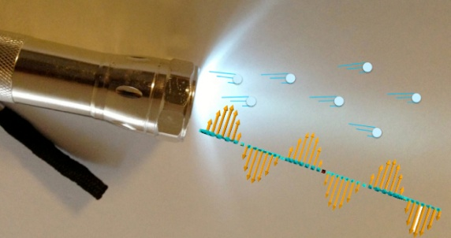](https://en.wikipedia.org/wiki/Photon)

Electron Fluctuation or spin

one line : When a laser light collide with solid particles the electrons of the atom will get spin between the orbitary layers of the atom

* [YOUTUBE](https://www.youtube.com/watch?v=J3xLuZNKhlY) - A nice animation video about the basic Electron Spin 1
* [YOUTUBE](https://www.youtube.com/watch?v=3k5IWlVdMbo) - A nice animation video about the basic Electron Spin 2
* [YOUTUBE](https://www.youtube.com/watch?v=jvvkomcmyuo) - A nice animation video about the basic Electron Spin 3

States

one line : Put a point on the spinning electron ,if the point is in the top then state 1 and its in bottom state 0

[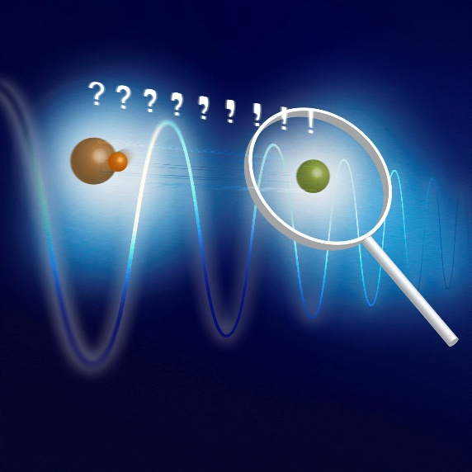](https://en.wikipedia.org/wiki/Quantum_state)

* [YOUTUBE](https://www.youtube.com/watch?v=sICXOwOwS4E) - A nice animation video about the Quantum States

SuperPosition

two line : During the spin of the electron the point may be in the middle of upper and lower position, So an effective decision needs to take on the point location either 0 or 1 . Better option to analyse it along with other electrons using probability and is called superposition

[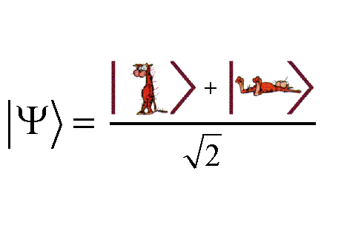](https://en.wikipedia.org/wiki/Quantum_superposition)

* [YOUTUBE](https://www.youtube.com/watch?v=hkmoZ8e5Qn0) - A nice animation video about the Quantum Superposition

SuperPosition specific for machine learning(Quantum Walks)

one line : As due to computational complexity ,quantum computing only consider superposition between limited electrons ,In case to merge more than one set quantum walk be the idea

* [YOUTUBE](https://www.youtube.com/watch?v=86QsYPxoBow) - A nice video about the Quantum Walks

Classical Bits

one line : If electron moved from one one atom to other ,from ground state to excited state a bit value 1 is used else bit value 0 used

Qubit

one line : The superposition value of states of a set of electrons is Qubit

[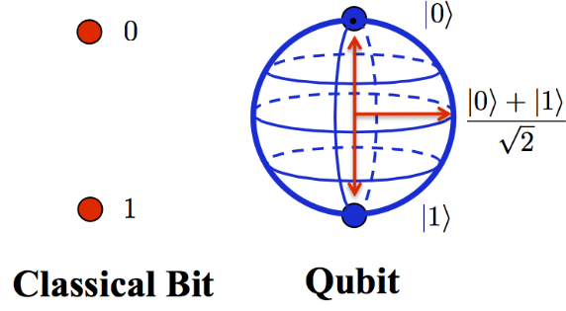](https://en.wikipedia.org/wiki/Qubit)

* [YOUTUBE](https://www.youtube.com/watch?v=zNzzGgr2mhk) - A nice video about the Quantum Bits 1
* [YOUTUBE](https://www.youtube.com/watch?v=F8U1d2Hqark&t=179s) - A nice video about the Bits and Qubits 2

Basic Gates in Quantum Computing

one line : As like NOT, OR and AND , Basic Gates like NOT, Hadamard gate , SWAP, Phase shift etc can be made with quantum gates

[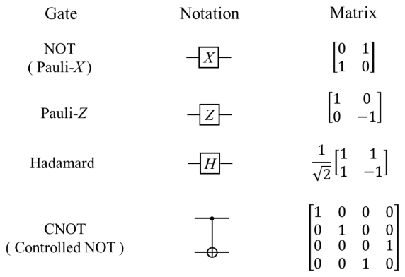](https://en.wikipedia.org/wiki/Quantum_gate)

* [YOUTUBE](https://www.youtube.com/watch?v=2Qsh_w2kq9Y) - A nice video about the Quantum Gates

Quantum Diode

one line : Quantum Diodes using a different idea from normal diode, A bunch of laser photons trigger the electron to spin and the quantum magnetic flux will capture the information

[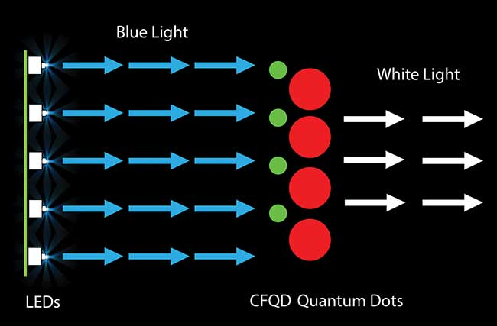](https://www.nature.com/articles/ncomms12978)

[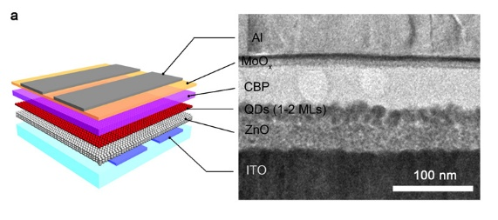](https://phys.org/news/2013-10-nanoscale-boosts-quantum-dot-emitting.html)

* [YOUTUBE](https://www.youtube.com/watch?v=doyK1olswX4) - A nice video about the Quantum Diode

Quantum Transistors

one line : A transistor default have Source ,drain and gate ,Here source is photon wave ,drain is flux and gate is classical to quantum bits

[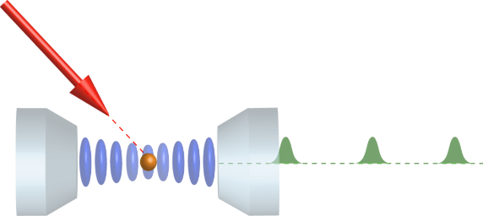](https://en.wikipedia.org/wiki/Magnetic_flux_quantum)

* [QUORA](https://www.quora.com/What-is-the-equivalent-of-the-transistor-in-a-quantum-computer) -Discussion about the Quantum Transistor
* [YOUTUBE](https://www.youtube.com/watch?v=ZTxR2n2mvjc) - Well Explained

Quantum Processor

one line : A nano integration circuit performing the quantum gates operation sorrounded by cooling units to reduce the tremendous amount of heat

[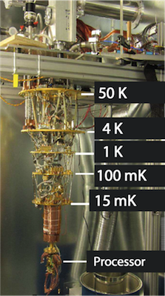](https://www.dwavesys.com/tutorials/background-reading-series/introduction-d-wave-quantum-hardware#h2-0)

[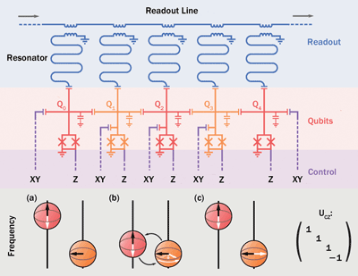](https://quantumexperience.ng.bluemix.net/qstage/?cm_mc_uid=36641337812614766932472&cm_mc_sid_50200000=1493295650#/user-guide)

[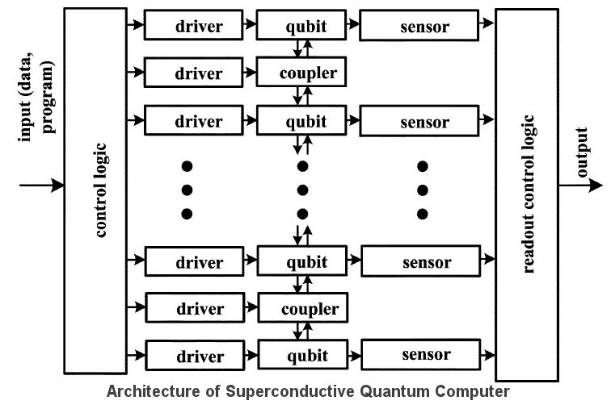](https://www.cbinsights.com/blog/quantum-computing-corporations-list/)

* [YOUTUBE](https://www.youtube.com/watch?v=CMdHDHEuOUE) - Well Explained

Quantum Registery QRAM

one line : Comapring the normal ram ,its ultrafast and very small in size ,the address location can be access using qubits superposition value ,for a very large memory set coherent superposition(address of address) be used

* [PDF](https://arxiv.org/pdf/0807.4994.pdf) - very Well Explained

QUANTUM COMPUTING MACHINE LEARNING BRIDGE

Complex Numbers

one line : Normally Waves Interference is in n dimensional structure , to find a polynomial equation n order curves ,better option is complex number

[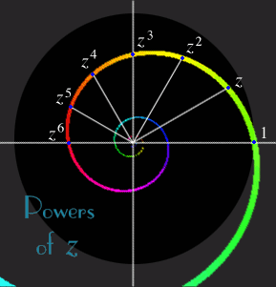](https://en.wikipedia.org/wiki/Complex_number)

[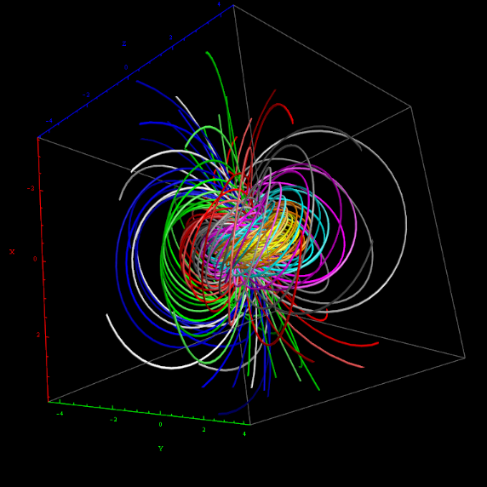](https://www.mathsisfun.com/numbers/complex-numbers.html)

[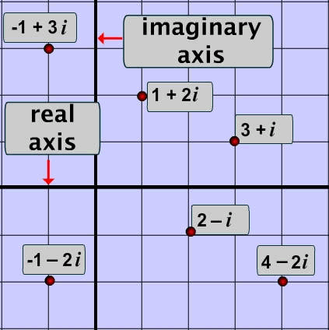](https://en.wikipedia.org/wiki/Complex_number)

* [YOUTUBE](https://www.youtube.com/watch?v=T647CGsuOVU) - Wonderful Series very super Explained

Tensors

one line : Vectors have a direction in 2D vector space ,If on a n dimensional vector space ,vectors direction can be specify with the tensor ,The best solution to find the superposition of a n vector electrons spin space is representing vectors as tensors and doing tensor calculus

[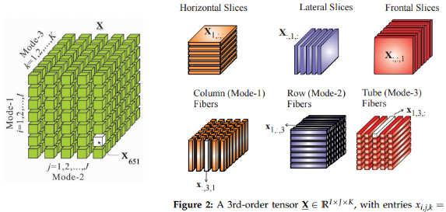](https://en.wikipedia.org/wiki/Tensor)

[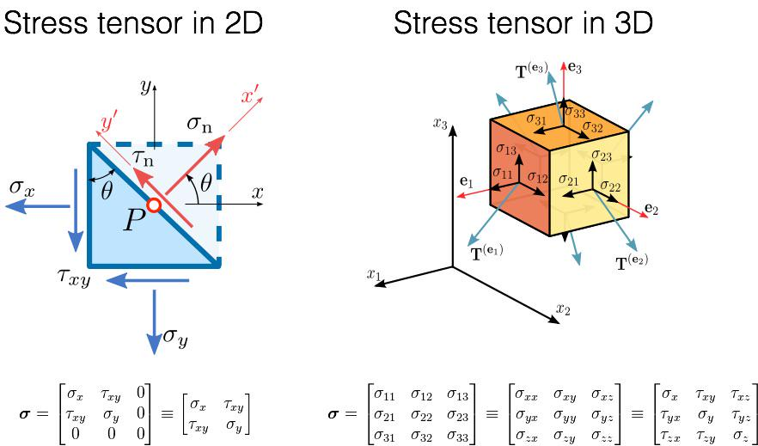](https://www.quantiki.org/wiki/tensor-product)

* [YOUTUBE](https://www.youtube.com/watch?v=f5liqUk0ZTw) - Wonderful super Explained tensors basics
* [YOUTUBE](https://www.youtube.com/watch?v=xzG6c96PsLs) - Quantum tensors basics

Tensors Network

one line : As like connecting multiple vectors ,multple tensors form a network ,solving such a network reduce the complexity of processing qubits

[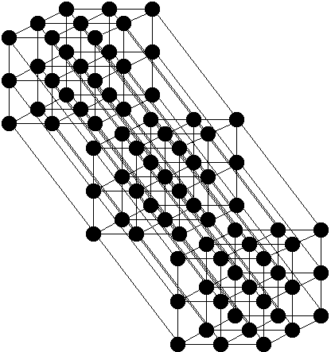](https://arxiv.org/pdf/1306.2164.pdf)

[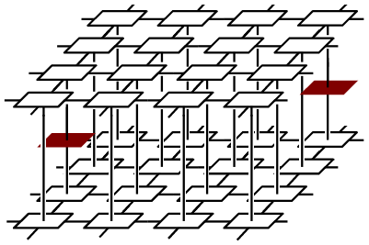](https://en.wikipedia.org/wiki/Tensor_network_theory)

* [YOUTUBE](https://www.youtube.com/watch?v=bD-CWgbsCeI&list=PLgKuh-lKre10UQnP7gBCFoKgq5KWIA7el) - Tensors Network Some ideas specifically for quantum algorithms

QUANTUM MACHINE LEARNING ALGORITHMS

Quantum K-Nearest Neighbour

info : Here the centroid(euclidean distance) can be detected using the swap gates test between two states of the qubit , As KNN is regerssive loss can be tally using the average

* [PDF1 from Microsoft](https://www.microsoft.com/en-us/research/publication/quantum-nearest-neighbor-algorithms-for-machine-learning/) - Theory Explanation
* [PDF2](https://arxiv.org/pdf/1409.3097.pdf) - A Good Material to understand the basics
* [Matlab](https://github.com/krishnakumarsekar/) - Yet to come soon
* [Python](https://github.com/krishnakumarsekar/) - Yet to come soon

Quantum K-Means

info : Two Approaches possible ,1. FFT and iFFT to make an oracle and calculate the means of superposition 2. Adiobtic Hamiltonian generation and solve the hamiltonian to determine the cluster

* [PDF1](https://pdfs.semanticscholar.org/6d77/54d33958b4a41d57ec99558eb28ae88f9884.pdf) - Applying Quantum Kmeans on Images in a nice way
* [PDF2](http://www.machinelearning.org/proceedings/icml2007/papers/518.pdf) - Theory
* [PDF3](https://arxiv.org/pdf/1307.0411.pdf) - Explaining well the K-means clustering using hamiltonian
* [Matlab](https://github.com/krishnakumarsekar/) - Yet to come soon
* [Python](https://github.com/krishnakumarsekar/) - Yet to come soon

Quantum Fuzzy C-Means

info : As similar to kmeans fcm also using the oracle dialect ,but instead of means,here oracle optimization followed by a rotation gate is giving a good result

* [PDF1](https://pdfs.semanticscholar.org/6d77/54d33958b4a41d57ec99558eb28ae88f9884.pdf) - Theory
* [Matlab](https://github.com/krishnakumarsekar/) - Yet to come soon
* [Python](https://github.com/krishnakumarsekar/) - Yet to come soon

Quantum Support Vector Machine

info : A little different from above as here kernel preparation is via classical and the whole training be in oracles and oracle will do the classification, As SVM is linear ,An optimal Error(Optimum of the Least Squares Dual Formulation) Based regression is needed to improve the performance

* [PDF1](https://arxiv.org/pdf/1307.0471.pdf) - Nice Explanation but little hard to understand :)
* [PDF2](http://www.scirp.org/journal/PaperInformation.aspx?paperID=72542) - Nice Application of QSVM
* [Matlab](https://github.com/krishnakumarsekar/) - Yet to come soon
* [Python](https://github.com/krishnakumarsekar/) - Yet to come soon

Quantum Genetic Algorithm

info : One of the best algorithm suited for Quantum Field ,Here the chromosomes act as qubit vectors ,the crossover part carrying by an evaluation and the mutation part carrying by the rotation of gates

* [PDF1](https://www.hindawi.com/journals/mpe/2013/730749/) - Very Beautiful Article , well explained and superp
* [PDF2](https://arxiv.org/pdf/1202.2026.pdf) - A big theory :)
* [PDF3](http://ccis2k.org/iajit/PDF/vol.9,no.3/2107-6.pdf) - Super Comparison
* [Matlab](http://www.codelooker.com/id/155/717734.html) - Simulation
* [Python1](https://github.com/ResearchCodesHub/QuantumGeneticAlgorithms/) - Simulation
* [Python2](https://github.com/krishnakumarsekar/) - Yet to come

Quantum Hidden Morkov Models

info : As HMM is already state based ,Here the quantum states acts as normal for the markov chain and the shift between states is using quantum operation based on probability distribution

* [PDF1](https://arxiv.org/pdf/1503.08760.pdf) - Nice idea and explanation
* [PDF2](https://arxiv.org/pdf/1207.4304.pdf) - Nice but a different concept little
* [Matlab](https://github.com/krishnakumarsekar/) - Yet to come
* [Python1](https://github.com/krishnakumarsekar/) - Yet to come
* [Python2](https://github.com/krishnakumarsekar/) - Yet to come

Quantum state classification with Bayesian methods

info : Quantum Bayesian Network having the same states concept using quantum states,But here the states classification to make the training data as reusable is based on the density of the states(Interference)

[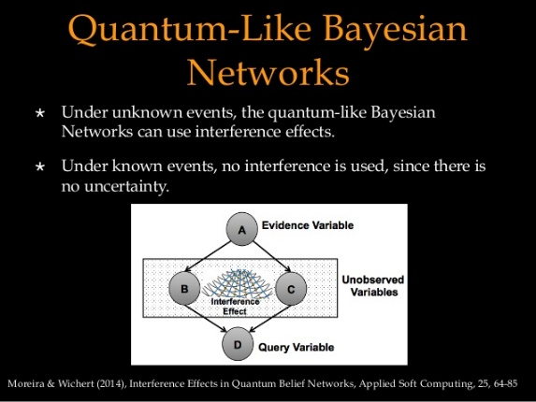](https://github.com/krishnakumarsekar/awesome-quantum-machine-learning/blob/master)

[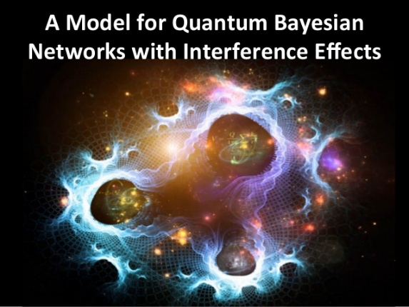](https://github.com/krishnakumarsekar/awesome-quantum-machine-learning/blob/master)

[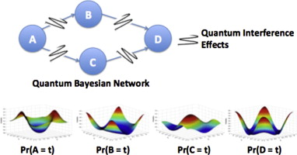](https://github.com/krishnakumarsekar/awesome-quantum-machine-learning/blob/master)

* [PDF1](https://arxiv.org/pdf/1204.1550.pdf) - Good Theory
* [PDF2](https://www.ncbi.nlm.nih.gov/pmc/articles/PMC4726808/) - Good Explanation
* [Matlab](https://github.com/krishnakumarsekar/) - Yet to come
* [Python1](https://github.com/krishnakumarsekar/) - Yet to come
* [Python2](https://github.com/krishnakumarsekar/) - Yet to come

Quantum Ant Colony Optimization

info : A good algorithm to process multi dimensional equations, ACO is best suited for Sales man issue , QACO is best suited for Sales man in three or more dimension, Here the quantum rotation circuit is doing the peromene update and qubits based colony communicating all around the colony in complex space

[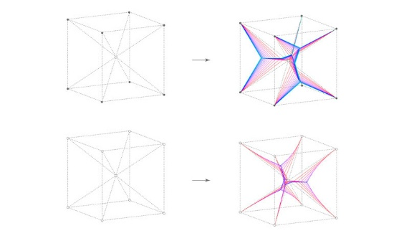](https://github.com/krishnakumarsekar/awesome-quantum-machine-learning/blob/master)

* [PDF1](http://ac.els-cdn.com/S2212667812001359/1-s2.0-S2212667812001359-main.pdf?_tid=42e0cd66-2f4a-11e7-920f-00000aacb361&acdnat=1493738345_8f536599e404c7588811ddd49c484688) - Good Concept
* [PDF2](http://www.sersc.org/journals/IJMUE/vol10_no11_2015/19.pdf) - Good Application
* [Matlab](https://github.com/krishnakumarsekar/) - Yet to come
* [Python1](https://github.com/krishnakumarsekar/) - Yet to come
* [Python2](https://github.com/krishnakumarsekar/) - Yet to come

Quantum Cellular Automata

info : One of the very complex algorithm with various types specifically used for polynomial equations and to design the optimistic gates for a problem, Here the lattice is formed using the quatum states and time calculation is based on the change of the state between two qubits ,Best suited for nano electronics

* [Wikipedia](https://en.wikipedia.org/wiki/Quantum_cellular_automaton) - Basic
* [PDF1](https://arxiv.org/pdf/0808.0679.pdf) - Just to get the keywords
* [PDF2](http://ieee-hpec.org/2013/index_htm_files/7-Improved-Eigensolver-Baldwin-2867489.pdf) - Nice Explanation and an easily understandable application
* [Matlab](https://github.com/krishnakumarsekar/) - Yet to come
* [Python1](https://github.com/krishnakumarsekar/) - Yet to come
* [Python2](https://github.com/krishnakumarsekar/) - Yet to come

QAUNTUM NEURAL NETWORK

[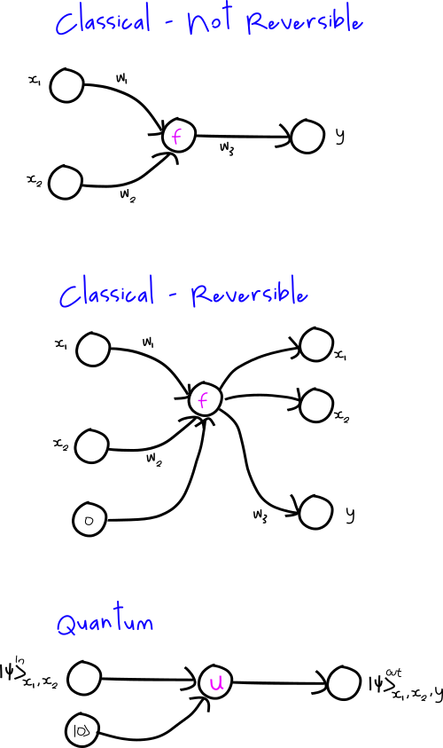](https://silky.github.io/posts/2016-12-11-quantum-neural-networks.html)

one line : Its really one of the hardest topic , To understand easily ,Normal Neural Network is doing parallel procss ,QNN is doing parallel of parallel processess ,In theory combination of various activation functions is possible in QNN ,In Normal NN more than one activation function reduce the performance and increase the complexity

Quantum perceptrons

info : Perceptron(layer) is the basic unit in Neural Network ,The quantum version of perceptron must satisfy both linear and non linear problems , Quantum Concepts is combination of linear(calculus of superposition) and nonlinear(State approximation using probability) ,To make a perceptron in quantum world ,Transformation(activation function) of non linearity to certain limit is needed ,which is carrying by phase estimation algorithm

[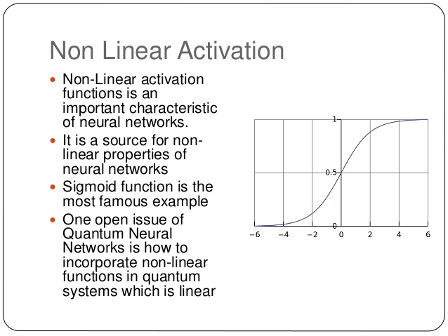](https://en.wikipedia.org/wiki/Activation_function)

[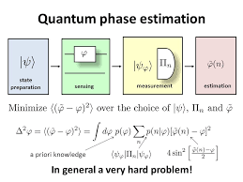](https://github.com/krishnakumarsekar/awesome-quantum-machine-learning/blob/master)

[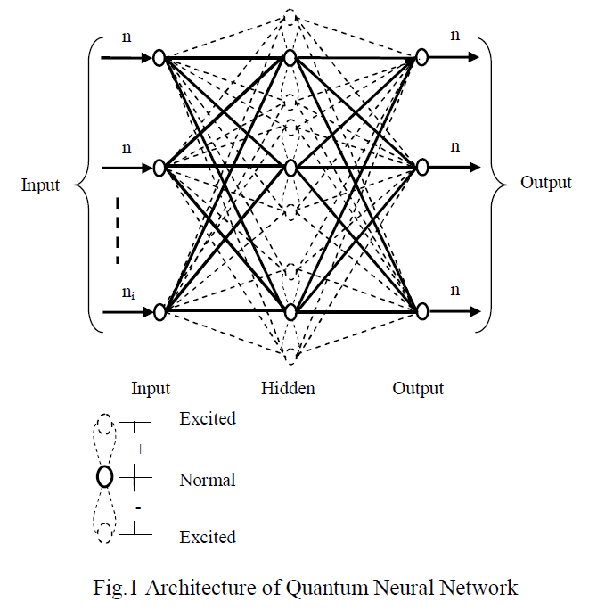](https://www.omicsonline.org/open-access/quantum-neural-network-based-parts-of-speech-tagger-for-hindi-0976-4860-5-137-152.pdf.php?aid=35658)

[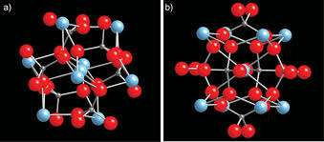](https://www.researchgate.net/publication/231178445_Quantum_Learning_and_Quantum_Perceptrons)

* [PDF1](https://arxiv.org/pdf/quant-ph/0201144.pdf) - Good Theory
* [PDF2](http://axon.cs.byu.edu/papers/ricks.nips03.pdf/) - Good Explanation
* [Matlab](https://github.com/krishnakumarsekar/) - Yet to come
* [Python1](https://github.com/krishnakumarsekar/) - Yet to come
* [Python2](https://github.com/krishnakumarsekar/) - Yet to come

QAUNTUM STATISTICAL DATA ANALYSIS

[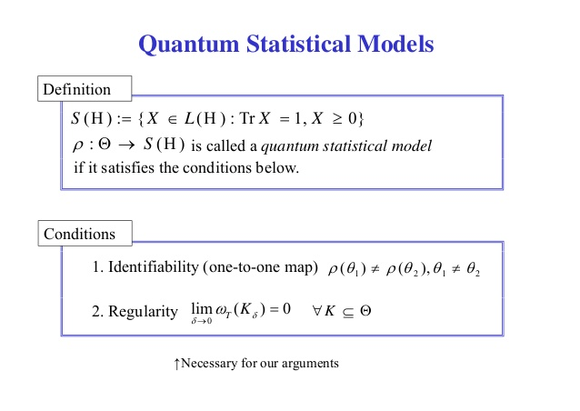](https://www.slideshare.net/tanafuyu/slide-2014-rims1031public)

[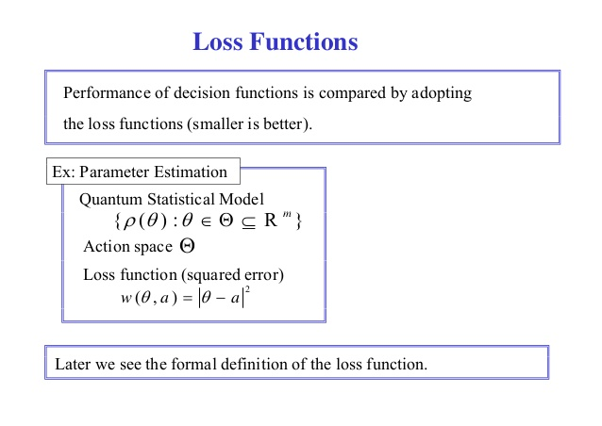](https://www.slideshare.net/tanafuyu/slide-2014-rims1031public)

[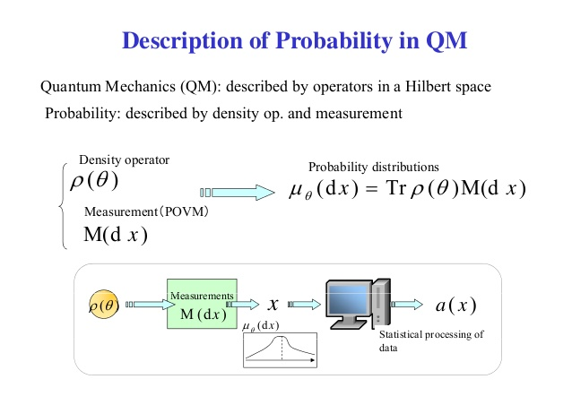](https://www.slideshare.net/tanafuyu/slide-2014-rims1031public)

[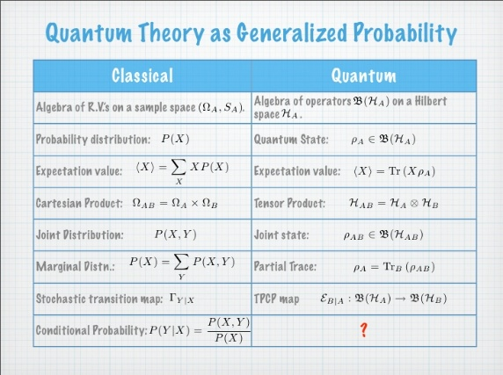](https://www.slideshare.net/mleifer/quantum-dynamics-as-generalized-conditional-probabilities)

[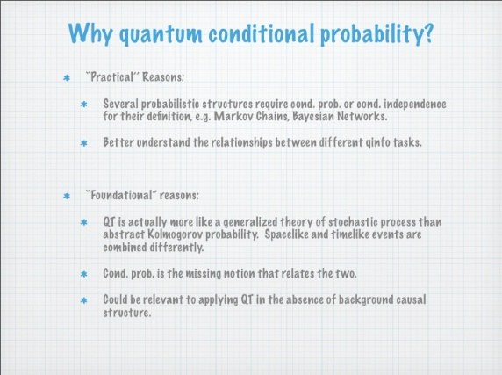](https://www.slideshare.net/mleifer/conditional-density-operators-in-quantum-information)

one line : An under research concept ,It can be seen in multiple ways, one best way if you want to apply n derivative for a problem in current classical theory its difficult to compute as its serialization problem instead if you do parallelization of differentiation you must estimate via probability the value in all flows ,Quantum Probability Helps to achieve this ,as the loss calculation is very less . the other way comparatively booming is Quantum Bayesianism, its a solution to solve most of the uncertainity problem in statistics to combine time and space in highly advanced physical research

QUANTUM PROGRAMMING LANGUAGES , TOOLs and SOFTWARES

All

info : All Programming languages ,softwares and tools in alphabetical order

* [Software](https://www.quantiki.org/wiki/list-qc-simulators) - Nice content of all
* [Python library](http://qutip.org/) - A python library
* [Matlab based python library](https://pypi.python.org/pypi/qit) - Matlab Python Library
* [Quantum Tensor Network Github](https://github.com/emstoudenmire/TNML) - Tensor Network
* [Bayesforge](http://bayesforge.com/) - A Beautiful Amazon Web Service Enabled Framework for Quantum Alogorithms and Data Analytics
* [Rigetti](https://github.com/rigetticomputing) - A best tools repository to use quantum computer in real time
* [Rigetti Forest](http://www.rigetti.com/index.php/forest) - An API to connect Quantum Computer
* [quil/pyQuil](http://pyquil.readthedocs.io/en/latest/overview.html) - A quantum instruction language to use forest framework
* [Grove](https://github.com/rigetticomputing/grove) - Grove is a repository to showcase quantum Fourier transform, phase estimation, the quantum approximate optimization algorithm, and others developed using Forest
* [QISKit](https://github.com/QISKit) - A IBM Kit to access quantum computer and mainly for quantum circuits
* [IBM Bluemix Simulator](https://quantumexperience.ng.bluemix.net/qx/editor) - A Bluemix Simulator for Quantum Circuits
* [Microsoft Quantum Development Kit](https://marketplace.visualstudio.com/items?itemName=quantum.DevKit) - Microsoft Visual Studio Enbaled Kit for Quantum Circuit Creation
* [Microsoft "Q#"](https://docs.microsoft.com/en-us/quantum/quantum-WriteAQuantumProgram?view=qsharp-preview) - Microsoft Q Sharp a new Programming Language for Quantum Circuit Creation
* [qiskit api python](https://github.com/QISKit/qiskit-api-py) - An API to connect IBM Quantum Computer ,With the generated token its easy to connect ,but very limited utils ,Lot of new utils will come soon
* [Cyclops Tensor Framework](http://solomon2.web.engr.illinois.edu/ctf/) - A framework to do tensor network simulations
* [Python ToolKit for chemistry and physics Quantum Algorithm simulations](https://github.com/qmlcode/qml) - A New Started Project for simulating molecule and solids
* [Bayesian Based Quatum Projects Repository](https://github.com/artiste-qb-net) - A nice repository and the kickstarter of bayesforge
* [Google Fermion Products](https://github.com/quantumlib) - A newly launched product specifivally for chemistry simulation
* [Tree Tensor Networks](https://github.com/dingliu0305/Tree-Tensor-Networks-in-Machine-Learning) - Interesting Tensor Network in Incubator
* [Deep Tensor Neural Network](https://github.com/atomistic-machine-learning/dtnn) - Some useful information about Tensor Neural Network in Incubator
* [Generative Tensorial Networks](http://gtn.ai/) - A startup to apply machine learning via tensor network for drug discovery
* [Google Bristlecone](https://research.googleblog.com/2018/03/a-preview-of-bristlecone-googles-new.html) - A new Quantum Processor from Google , Aimed for Future Hardwares with full fledged AI support
* [XANADU](https://www.xanadu.ai/) - A Light based Quantum Hardware(chips supports) and Software Company Started in Preparation Stage. Soon will be in market
* [fathom computing](https://www.fathomcomputing.com/) - A new concept to train the ai in a processor using light and quantum based concepts. soon products will be launch
* [Alibaba Quantum Computing Cloud Service](https://www.alibabacloud.com/press-room/alibaba-cloud-and-cas-launch-one-of-the-worlds-most) - Cloud Service to access 11 Bit Quantum Computing Processor
* [Atomistic Machine Learning Project](https://github.com/atomistic-machine-learning) - Seems something Interesting with Deep Tensor Network for Quantum Chemistry Applications
* [circQ and Google Works](https://ai.google/research/teams/applied-science/quantum/) - Google Top Efforts on Tools
* [IBM Safe Cryptography on Cloud](https://www.sdxcentral.com/articles/news/ibm-drives-quantum-safe-cryptography-into-its-public-cloud/2019/08/) - IBM Started and Developing a Quantm Safe Cryptography to replace all our Certificate Authority via Cloud
* [Google Tensor Network Open Source](https://ai.googleblog.com/2019/06/introducing-tensornetwork-open-source.html) - Google Started the Most Scientist Preferred Way To Use a Quantum Computer Circuit. Tensor Flow Which Makes Easy to Design the Network and Will Leave the Work Effect Of Gates, Processor Preparation and also going to tell the beauty of Maths
* [Google Tensor Network Github](https://github.com/google/TensorNetwork) - Github Project of Google Tensor Network
* [Quantum Tensorflow](https://github.com/krishnakumarsekar/) - Yet to come soon
* [Quantum Spark](https://github.com/krishnakumarsekar/) - Yet to come soon
* [Quatum Map Reduce](https://github.com/krishnakumarsekar/) - Yet to come soon
* [Quantum Database](https://github.com/krishnakumarsekar/) - Yet to come soon
* [Quantum Server](https://github.com/krishnakumarsekar/) - Yet to come soon
* [Quantum Data Analytics](https://github.com/krishnakumarsekar/) - Yet to come soon

QUANTUM HOT TOPICS

Deep Quantum Learning

why and what is deep learning?

In one line , If you know deep learning you can get a good job :) ,Even a different platform undergraduated and graduated person done a master specialization in deep learning can work in this big sector :), Practically speaking machine learning (vector mathematics) , deep learning (vector space(Graphics) mathematics) and big data are the terms created by big companies to make a trend in the market ,but in science and research there is no word such that , Now a days if you ask a junior person working in this big companies ,what is deep learning ,you will get some reply as "doing linear regression with stochastic gradient for a unsupervised data using Convolutional Neural Network :)" ,They knows the words clearly and knows how to do programming using that on a bunch of "relative data" , If you ask them about the FCM , SVM and HMM etc algorithms ,they will simply say these are olden days algorithms , deep learning replaced all :), But actually they dont know from the birth to the till level and the effectiveness of algorithms and mathematics ,How many mathematical theorems in vector, spaces , tensors etc solved to find this "hiding the complexity technology", They did not played with real non relative data like medical images, astro images , geology images etc , finding a relation and features is really complex and looping over n number of images to do pattern matching is a giant work , Now a days the items mentioned as deep learning (= multiple hidden artifical neural network) is not suitable for that

why quantum deep learning or deep quantum learning?

In the mid of Artificial Neural Network Research people realised at the maximum extreme only certain mathematical operations possible to do with ANN and the aim of this ANN is to achieve parallel execution of many mathematical operations , In artificial Intelligence ,the world intelligence stands for mathematics ,how effective if a probem can be solvable is based on the mathematics logic applying on the problem , more the logic will give more performance(more intelligent), This goal open the gate for quantum artificial neural network, On applying the ideas behind the deep learning to quantum mechanics environment, its possible to apply complex mathematical equations to n number of non relational data to find more features and can improve the performance

Quantum Machine Learning vs Deep Learning

Its fun to discuss about this , In recent days most of the employees from Product Based Companies Like google,microsoft etc using the word deep learning ,What actually Deep Learning ? and is it a new inventions ? how to learn this ? Is it replacing machine learning ? these question come to the mind of junior research scholars and mid level employees

The one answer to all questions is deep learning = parallel "for" loops ,No more than that ,Its an effective way of executing multiple tasks repeatly and to reduce the computation cost, But it introduce a big cap between mathematics and computerscience , How ?

All classical algorithms based on serial processing ,Its depends on the feedback of the first loop ,On applying a serial classical algorithm in multiple clusters wont give a good result ,but some light weight parallel classical algorithms(Deep learning) doing the job in multiple clusters and its not suitable for complex problems, What is the solution for then?

As in the title Quantum Machine Learning ,The advantage behind is deep learning is doing the batch processing simply on the data ,but quantum machine learning designed to do batch processing as per the algorithm

The product companies realised this one and they started migrating to quantum machine learning and executing the classical algorithms on quantum concept gives better result than deep learning algorithms on classical computer and the target to merge both to give very wonderful result

References

* [Quora](https://www.quora.com/How-will-quantum-computing-revolutionize-deep-learning) - Good Discussion
* [Quora](https://www.quora.com/Will-quantum-computing-change-machine-learning) - The Bridge Discussion
* [Pdf](http://www.scottaaronson.com/papers/qml.pdf) - Nice Discussion
* [Google](https://venturebeat.com/2015/11/11/google-researcher-quantum-computers-arent-perfect-for-deep-learning/) - Google Research Discussion
* [Microsoft](http://www.physics.usyd.edu.au/quantum/Coogee2015/Presentations/Svore.pdf) - Microsoft plan to merge both
* [IBM](https://www.rtinsights.com/ibm-quantum-computing-with-machine-learning-in-cloud/) - IBM plan to merge both
* [IBM Project](https://www.ibm.com/blogs/research/2017/03/quantum-algorithm-classifies-9500-handwritten-numbers/) - IBM Project idea
* [MIT and Google](https://www.technologyreview.com/s/544421/googles-quantum-dream-machine/) - Solutions for all questions

QUANTUM MEETUPS

* [Meetup 1](https://www.meetup.com/Quantum-Physics-Drinks/) - Quantum Physics
* [Meetup 2](https://www.meetup.com/London-Quantum-Computing-Meetup/) - Quantum Computing London
* [Meetup 3](https://www.meetup.com/New-York-Quantum-Computing-Meetup/) - Quantum Computing New York
* [Meetup 4](https://www.meetup.com/Quantum-Computing-and-Big-Data/events/238749477/) - Quantum Computing Canada
* [Meetup 5](https://www.meetup.com/Austin-Quantum-Computing-Artificial-Intelligence-Meetup/) - Quantum Artificial Intelligence Texas
* [Meetup 6](https://www.meetup.com/The-NY-Quantum-Theory-Group/) - Genarl Quantum Mechanics , Mathematics New York
* [Meetup 7](https://www.meetup.com/Quantum-Computers/) - Quantum Computing Mountain View California
* [Meetup 8](https://www.meetup.com/nyhackr/) - Statistical Analysis New York
* [Meetup 9](https://www.meetup.com/Quantum-Physics-Meetup-Group/) - Quantum Mechanics London UK
* [Meetup 10](https://www.meetup.com/Quantum-Physics-Drinks/) - Quantum Physics Sydney Australia
* [Meetup 11](https://www.meetup.com/Berkeley-Quantum-Physics-Spirituality-Meetup/) - Quantum Physics Berkeley CA
* [Meetup 12](https://www.meetup.com/QuantumX-Quantum-Computing-Meetup/) - Quantum Computing London UK
* [Meetup 13](https://www.meetup.com/Carmichael-Quantum-Christians/) - Quantum Mechanics Carmichael CA
* [Meetup 14](https://www.meetup.com/Relativity-Exploration-of-Portland/) - Maths and Science Group Portland
* [Meetup 15](https://www.meetup.com/Quantum-Physics-Discussion-Group/) - Quantum Physics Santa Monica, CA
* [Meetup 16](https://www.meetup.com/Quantum-Vibrational-Healing/) - Quantum Mechanics London
* [Meetup 17](https://www.meetup.com/London-Quantum-Computing-Meetup/) - Quantum Computing London
* [Meetup 18](https://www.meetup.com/quantum-metaphysics/) - Quantum Meta Physics ,Kansas City , Missouri ,US
* [Meetup 19](https://www.meetup.com/Quantum-Content/) - Quantum Mechanics and Physics ,Boston ,Massachusetts ,US
* [Meetup 20](https://www.meetup.com/Quantum-Organization/) - Quantum Physics and Mechanics ,San Francisco ,California
* [Meetup 21](https://www.meetup.com/Theoretical-Quantum-Mechanics/) - Quantum Mechanics ,Langhorne, Pennsylvania
* [Meetup 22](https://www.meetup.com/Portland-Science-Meetup/) - Quantum Mechanics ,Portland

QUANTUM BASED DEGREES

Plenty of courses around the world and many Universities Launching it day by day ,Instead of covering only Quantum ML , Covering all Quantum Related topics gives more idea in the order below

Available Courses

Quantum Mechanics for Science and Engineers

* Online
  + [Standford university](http://online.stanford.edu/course/qmse01-quantum-mechanics-scientists-and-engineers) - Nice Preparatory Course
  + [edx](https://courses.edx.org/courses/course-v1:GeorgetownX+PHYX-008-01x+1T2017/info) - Quantum Mechanics for Everyone
  + [NPTEL 1](http://nptel.ac.in/courses/115104096/) - Nice Series of Courses to understand basics and backbone of quantum mechanics
  + [NPTEL 2](http://nptel.ac.in/courses/115102023/)
  + [NPTEL 3](http://nptel.ac.in/courses/115106066/)
  + [NPTEL 4](http://nptel.ac.in/courses/115108074/)
  + [NPTEL 5](http://nptel.ac.in/courses/115101010/)
* Class Based Course
  + UK
    - [Bristol](http://www.bristol.ac.uk/maths/study/undergraduate/units1617/levelh6units/quantum-mechanics-math35500/)
  + Australia
    - [Australian National University](http://programsandcourses.anu.edu.au/course/PHYS2013)
  + Europe
    - [Maxs Planks University](http://programsandcourses.anu.edu.au/course/PHYS2013)

Quantum Physics

* Online
  + [MIT](https://ocw.mit.edu/courses/physics/8-04-quantum-physics-i-spring-2013/lecture-videos/) - Super Explanation and well basics
  + [NPTEL](http://nptel.ac.in/courses/122106034/) - Nice Series of Courses to understand basics and backbone of quantum Physics
* Class Based Course
  + Europe
    - [University of Copenhagen](http://www.nbi.ku.dk/english/research/quantum-physics/)

Quantum Chemistry

* Online
  + [NPTEL 1](http://nptel.ac.in/courses/104108057/) - Nice Series of Courses to understand basics and backbone of quantum Chemistry
  + [NPTEL 2](http://nptel.ac.in/courses/104106083/) -
* Class Based Course
  + Europe
    - [UGent Belgium](http://www.quantum.ugent.be/)

Quantum Computing

* Online
  + [MIT](https://ocw.mit.edu/courses/mathematics/18-435j-quantum-computation-fall-2003/index.htm) - Super Explanation and well basics
  + [edx](https://www.edx.org/course/quantum-mechanics-quantum-computation-uc-berkeleyx-cs-191x) - Nice Explanation
  + [NPTEL](http://nptel.ac.in/courses/104104082/) - Nice Series of Courses to understand basics and backbone of quantum Computing
* Class Based Course
  + Canada
    - [uwaterloo](https://uwaterloo.ca/institute-for-quantum-computing/)
  + Singapore
    - [National University Singapore](http://www.quantumlah.org/)
  + USA
    - [Berkley](http://www.quantumlah.org/)
  + China
    - [Baidu](https://medium.com/@Synced/baidu-launches-institute-of-quantum-computing-899454cbe1c5)

Quantum Technology

* Class Based Course
  + Canada
    - [uwaterloo](https://uwaterloo.ca/institute-for-quantum-computing/)
  + Singapore
    - [National University Singapore](http://www.quantumlah.org/)
  + Europe
    - [Munich](http://www.munich-quantum-center.de/index.php?id=1)
  + Russia
    - [Skoltech](http://crei.skoltech.ru/cpqm)

Quantum Information Science

* External Links
  + [quantwiki](https://www.quantiki.org/wiki/courses-quantum-information-science)
* Online
  + [MIT](https://ocw.mit.edu/courses/media-arts-and-sciences/mas-865j-quantum-information-science-spring-2006/) - Super Explanation and well basics
  + [edx](https://www.edx.org/course/quantum-information-science-ii-mitx-8-371x) - Nice Explanation
  + [NPTEL](http://nptel.ac.in/courses/115101092/) - Nice Series of Courses to understand basics and backbone of quantum information and computing
* Class Based Course
  + USA
    - [MIT](http://qis.mit.edu/)
    - [Standford University](https://web.stanford.edu/group/yamamotogroup/)
    - [Joint Center for Quantum Information and Computer Science - University of Maryland](http://quics.umd.edu/)
  + Canada
    - [Perimeter Institute](https://perimeterinstitute.ca/research/research-areas/quantum-information)
  + Singapore
    - [National University Singapore](http://www.quantumlah.org/)
  + Europe
    - [ULB Belgium](http://quic.ulb.ac.be/teaching)
    - [IQOQI](https://iqoqi.at/en)

Quantum Electronics

* Online
  + [MIT](https://ocw.mit.edu/courses/electrical-engineering-and-computer-science/6-974-fundamentals-of-photonics-quantum-electronics-spring-2006/) - Wonderful Course
  + [NPTEL](http://nptel.ac.in/courses/115102022/) - Nice Series of Courses to understand basics and backbone of quantum Electronics
* Class Based Course
  + USA
    - [Texas](http://www.ece.utexas.edu/research/areas/plasma-quantum-electronics-and-optics)
  + Europe
    - [Zurich](http://www.iqe.phys.ethz.ch/utils/contact.html)
    - [ICFO](http://quantumtech.icfo.eu/)
  + Asia
    - [Tata Institute](http://www.tifr.res.in/~quantro/index.html)

Quantum Field Theory

* Online
  + [Standford university](https://ocw.mit.edu/courses/physics/8-323-relativistic-quantum-field-theory-i-spring-2008/) - Nice Preparatory Course
  + [edx](https://www.edx.org/course/effective-field-theory-mitx-8-eftx) - Some QFT Concepts available
* Class Based Course
  + UK
    - [Imperial](http://www.imperial.ac.uk/theoretical-physics/postgraduate-study/msc-in-quantum-fields-and-fundamental-forces/)
  + Europe
    - [Vrije](http://www.vub.ac.be/en/study/fiches/56659/quantum-field-theory)

Quantum Computer Science

* Class Based Course
  + USA
    - [Oxford](https://www.cs.ox.ac.uk/teaching/courses/quantum/)
    - [Joint Center for Quantum Information and Computer Science - University of Maryland](http://quics.umd.edu/)

Quantum Artificial Intelligence and Machine Learning

* External Links
  + [Quora 1](https://www.quora.com/Quantum-Computing-vs-Artificial-Intelligence-for-a-PhD)
  + [Quora 1](https://www.quora.com/Where-can-you-get-a-PhD-in-quantum-machine-learning)
  + [Artificial Agents Research for Quantum Designs](https://www.uibk.ac.at/newsroom/artificial-agent-designs-quantum-experiments.html.en)

Quantum Mathematics

* Class Based Course
  + USA
    - [University of Notre ***](http://acms.nd.edu/research/)

CONSOLIDATED Quantum Research Papers

* [scirate](https://scirate.com/) - Plenty of Quantum Research Papers Available
* [Peter Wittek](http://peterwittek.com/book.html) - Famous Researcher for the Quantum Machine Leanrning , Published a book in this topic
* [Murphy Yuezhen Niu] (<https://scholar.google.com/citations?user=0wJPxfkAAAAJ&hl=en>) - A good researcher published some nice articles

Recent Quantum Updates forum ,pages and newsletter

* [Quantum-Tech](https://medium.com/quantum-tech) - A Beautiful Newsletter Page Publishing Amazing Links
* [facebook Quantum Machine Learning](https://www.facebook.com/quantummachinelearning) - Running By me . Not that much good :). You can get some ideas
* [Linkedlin Quantum Machine Learning](https://www.linkedin.com/groups/8592758) - A nice page running by experts. Can get plenty of ideas
* [FOSDEM 2019 Quantum Talks](https://fosdem.org/2019/schedule/track/quantum_computing/) - A one day talk in fosdem 2019 with more than 10 research topics,tools and ideas
* [FOSDEM 2020 Quantum Talks](https://fosdem.org/2020/schedule/track/quantum_computing/) - Live talk in fosdem 2020 with plenty new research topics,tools and ideas

License

Dedicated Opensources

* Source code of plenty of Algortihms in Image Processing , Data Mining ,etc in Matlab, Python ,Java and VC++ Scripts
* Good Explanations of Plenty of algorithms with flow chart etc
* Comparison Matrix of plenty of algorithms
* [Is Quantum Machine Learning Will Reveal the Secret Maths behind Astrology?](https://medium.com/@krishnakumar070891/is-quantum-machine-learning-will-reveal-the-secret-maths-behind-astrology-ce69fd71a019)
* Awesome Machine Learning and Deep Learning Mathematics is [online](https://github.com/krishnakumarsekar/awesome-machine-learning-deep-learning-mathematics)
* Published Basic Presentation of the series Quantum Machine Learning

[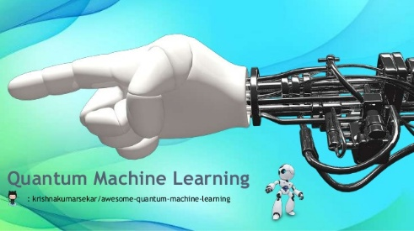](https://docs.google.com/presentation/d/1sqQu3LhX97OIwIEEvDMpzQRh6x52C9XDs1RkbPBM9uM/present)

[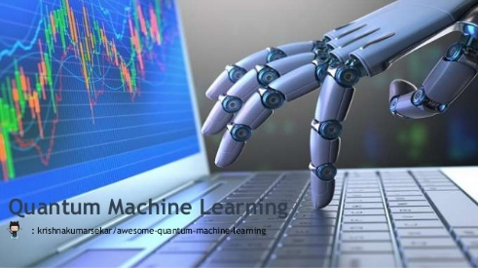](https://docs.google.com/presentation/d/1TBmkOkfeIifT73p2ENtnU75JgzMXqj9sOPws378-DPc/present)

Contribution

* If you think this page might helpful. Please help for World Education Charity or kids who wants to learn

[](https://github.com/krishnakumarsekar/awesome-quantum-machine-learning/blob/master/contribution.md)